**CHAPTER - 1**

**INTRODUCTION**

**CHAPTER 1**

# **INTRODUCTION**

**General**

**ArtScience Museum** is a museum within the integrated resort of Marina Bay Sands in the Downtown core of the Central area in Singapore. Opened on 17 February 2011 by Singapore's Prime Minister Lee Hsien Loong, it is the world's first ArtScience museum, featuring major exhibitions that blend art, science, culture and technology. The ArtScience Museum is a key permanent attraction of the Marina Bay Sands Integrated Resort located at Bayfront Avenue.The largest private museum in Singapore, it focuses on the connections between art and science through hi-tech exhibits that push disciplinary boundaries. Designed by world-renown architect Moshe Safdie, the museum is in the shape of a lotus with 10 irregular petals. This unique structure features over 5500M2of galleries housing the permanent and touring exhibitions, and embraces a spectrum of influences from the relationship between art and science, to media and technology, to design and architecture.

An iconic presence along the Marina Bay waterfront in Singapore, ArtScience Museum is a living, breathing embodiment of the ArtScience theme. The museum’s combination of striking architecture, award-winning design, strong and intellectual discussions makes it’s unique internationally. The museum hosts major international touring exhibitions giving Singaporeans and tourists the possibility to enjoy in Art and Science from all over the world.

The architecture of the museum is perhaps one of the most interesting designs in the area and stands out when surrounded by rectangular shaped buildings. Building is also known like **“The Welcoming Hand of Singapore.”**

The concept is that each finger stands for different gallery spaces which have supporting skylights at the fingertips which provide a sustainable illumination for the curved interior walls. A master class in green architecture, ArtScience museum features 21 gallery spaces totaling 50,000 square feet (6,000 m2) that delivering exhibits from art and science, design and architecture, to media and technology.

In total, there are three levels of galleries linked with large elevators and escalators carrying the public from lower to upper galleries.

The asymmetrical museum structure is composed by double-curved fiber reinforced polymer skin typically used at such a scale in the construction of boats and yachts with the vertical sides of each petal sheathed in bead-blasted stainless steel panels. It reaches upward into the skyline as high as 60 meters. This assembly is supported by ten columns and tied down at its center by a basket, sculptural centerpiece. The result in an efficient resolution of the structural forces for the building, giving it a seemingly weightless quality as it hovers above the ground.

**The building has some interesting sustainability features as well.**The dish-like roof form collects rainwater and drains it through an oculus, creating central waterfall in the building. The recirculated water is filtered and used for the restroom facilities.

The ArtScience Museum offers a wonderful display of art and science across numerous cultures and centuries.

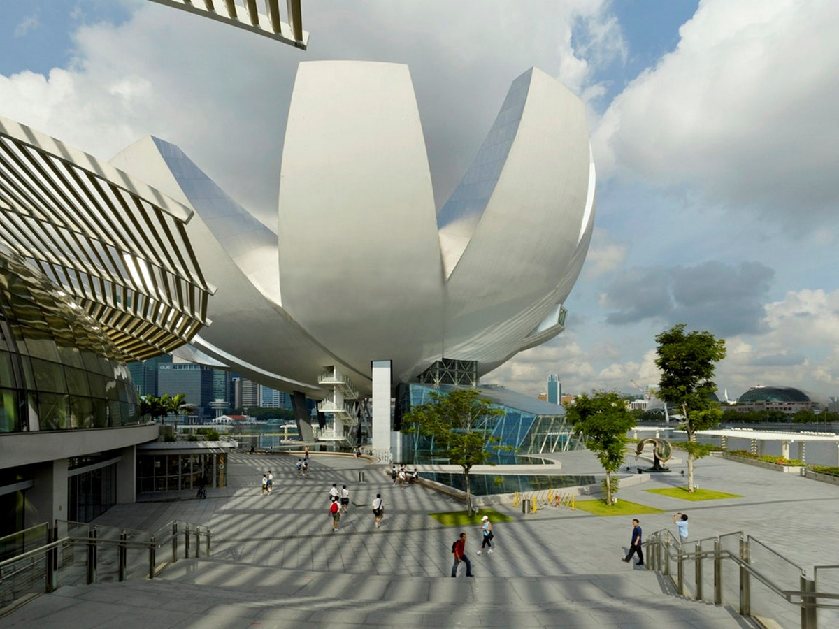

**Fig 1.1 ArtScience Museum**

**CHAPTER - 2**

**LOCATION**

**CHAPTER 2**

# **LOCATION**

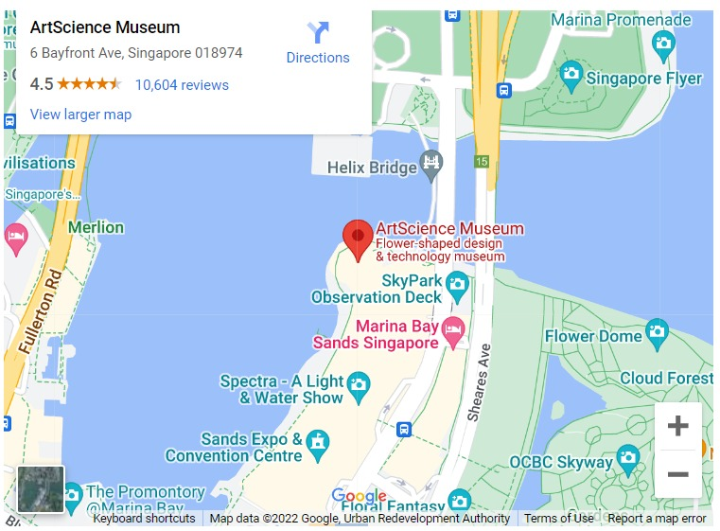

**Address:** #Marina Bay Sands 6 Bayfront Avenue, Singapore 018974

**CHAPTER - 3**

**PLAN**

**CHAPTER 3**

# **PLAN**

The ArtScience Museum located along the Marina Bay Sands waterfront co-locates exhibits that bridge the relationship between Arts and Sciences. The museum is organized as two major exhibition spaces, positioned around a central open-space atrium. The first exhibits hover within a sculpturally shaped form over the promenade, and a second collection of gallery spaces are located beneath a large water lily garden.

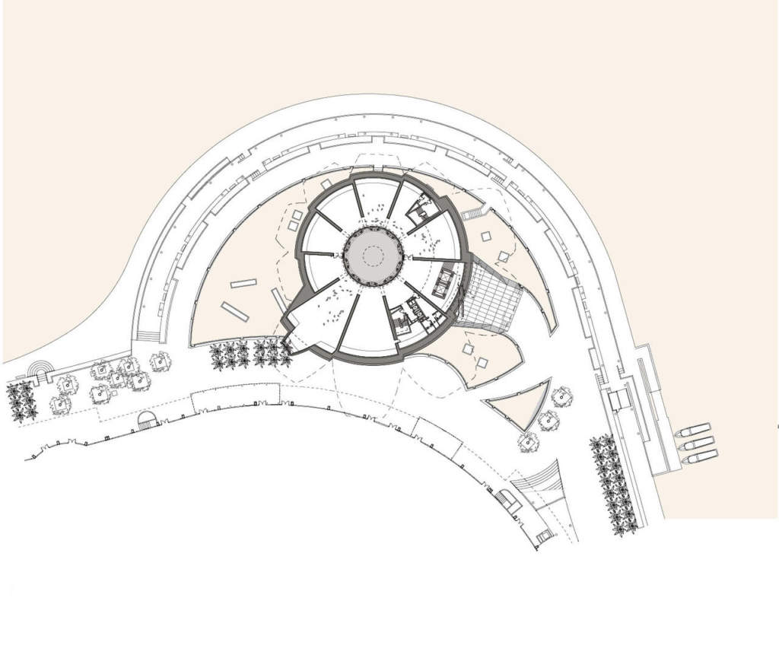

**Fig 3.1 Top view of ArtScience Museum**

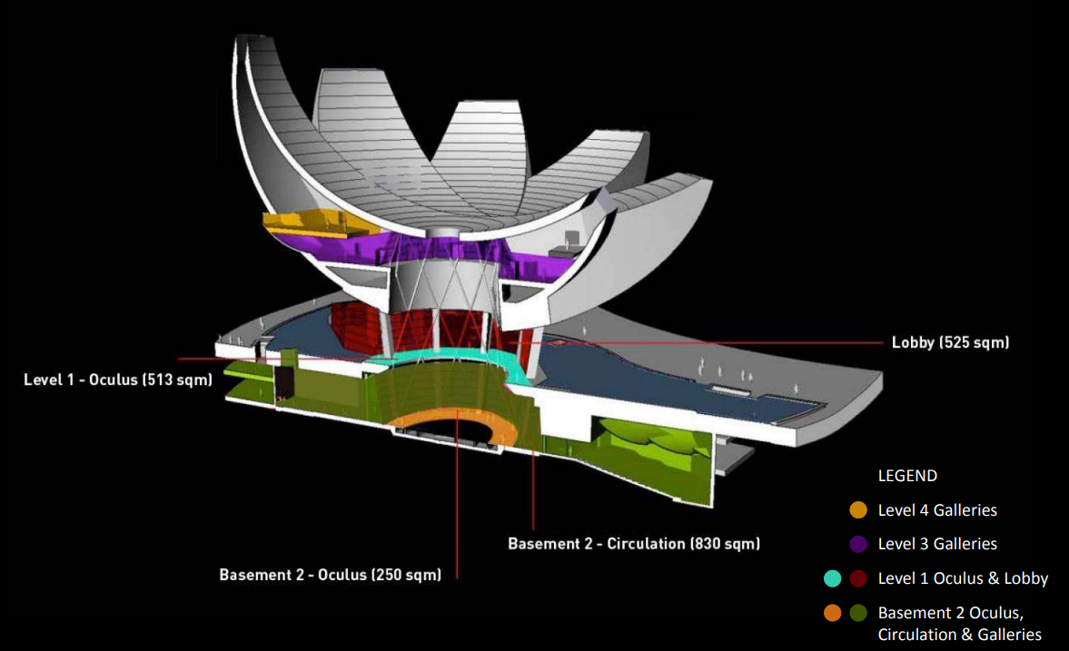

**Fig 3.2 Section view of ArtScience Museum**

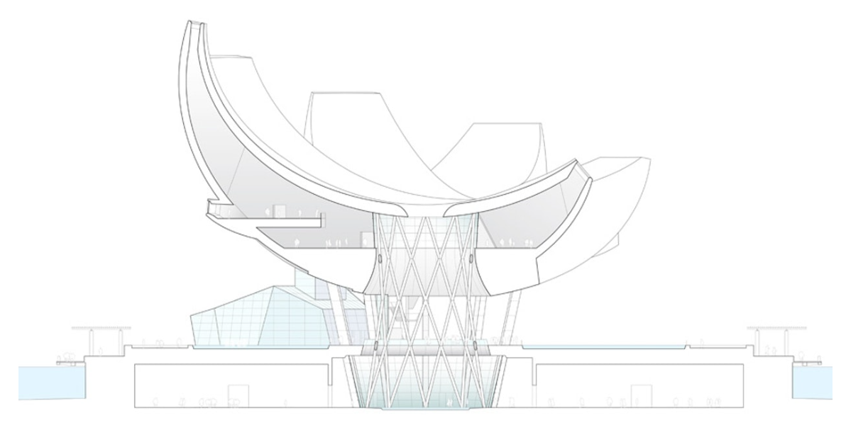

Tension and compression rings resist the push-pull action of the cantilevering mega trusses which support the elevated galleries of the ArtScience Museum. The hyperbolic diagrid provides primary lateral stability to the entire system. Courtesy of Patrick S. McCafferty.

**BASEMENT-1**

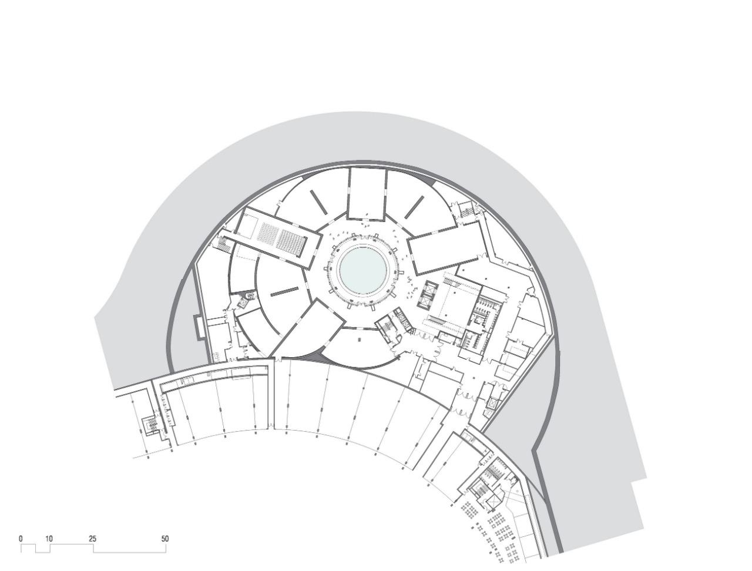

**Fig 3.3 Basement 1**

**BASEMENT-2&3**

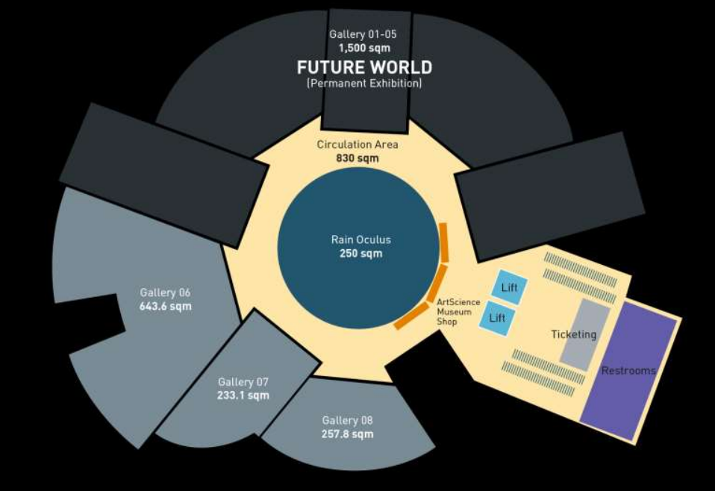

**Fig 3.4 Basement 2&3**

**CHAPTER - 4**

**ARCHITECTURE**

**CHAPTER 4**

# **ARCHITECTURE**

The ArtScience Museum has 21 gallery spaces with a total area of 64,583 square feet (6,000 square meters).

The upper galleries are organized into 10 halls that vary from double height vertical spaces, to long horizontal rooms. Each hall has access to daylight from skylights above and from the central atrium. Integrated lighting control mechanisms allow the spaces to be transformed to black boxes. Large picture windows from within the galleries offer views to the promenade below.

The building is supported by a steel lattice diagrid structure and ten steel columns –a sculptural centerpiece that allows the building to seemingly float above. The geometry of the shape is often compared to a lotus, and is clad with fiber-reinforced polymer (FRP), typically used in high-performance racing yachts.

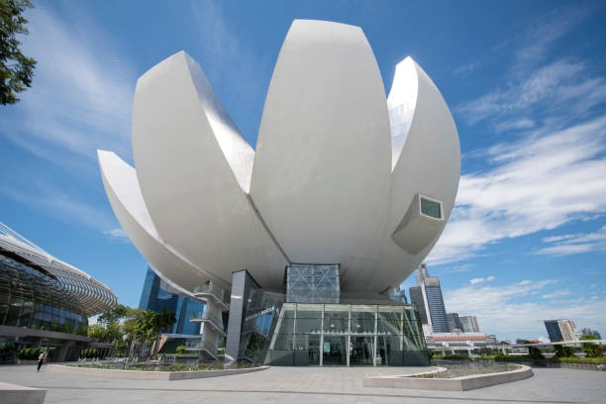

**Fig 4.1 ArtScience Museum Architecture**

* **SUSTAINABILITY FEATURES**

The dish-shaped roof form collects rainwater and drains it through an oculus, creating a waterfall through the open-air atrium of the museum.

Rainwater is harvested and channeled down the center of the building, flowing through its bowl-shaped roof into a reflecting pond at the lowest level of the building. The rainwater is then recycled for use in the building's restrooms.

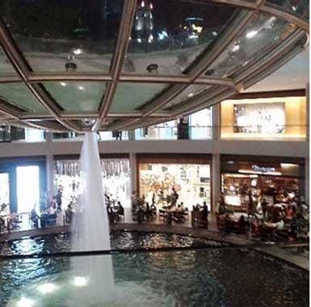

**CHAPTER - 5**

**DESIGN**

**CHAPTER 5**

# **DESIGN**

**The design of the museum is conceptualized in two parts:**

* The flowerlike superstructure made of ten petals seemingly a float in a giant lily pond, and the base, embedded beneath the same waterbody.
* The museum is composed of twenty-one galleries spread over 3 stories, across 6,000 square meters of floor space.
* The ten upper galleries vary in shape and height, making the discovery of each new space an exciting experience.
* Double-height vertical spaces transition seamlessly into long horizontal rooms, each cleverly illuminated by sunlight filtering in through the skylights above as well as the central atrium.
* The galleries also have picture windows that frame expansive views of the breath taking waterfront.

**GEOMETRY OF A FLOWER**

The tip of each ‘petal’ is capped with a skylight to let in abundant natural light. This feature is a sustainable way to illuminate the curved walls and gallery spaces within. When required by the nature of the exhibit, the galleries can be transformed into black boxes with the help of integrated lighting technology. The precise curves of the petals were generated by intersecting spheroids of varying radii. They rise from the pond in varying heights, with the tallest reaching 60 m into the sky above. Each doubly curved surface is sheathed in a fibre-reinforced polymer skin to achieve a seamless finish. This is a material typically used in the construction of boats and yachts. The joint less gleaming white surfaces lend lightness to the structure that reinforces the concept of a floating lotus. The vertical side panels of the petals are cladded in bead-blasted stainless steel panels. The gently curving concave roof collects rainwater which drains through an oculus, forming a central waterfall. The water then feeds an indoor pond at the base of the atrium.

* The precise curves of the petals were generated by intersecting spheroids of varying radii. They rise from the pond in varying heights, with the tallest reaching 60 m into the sky above.
* Each doubly curved surface is sheathed in a fiber-reinforced polymer skin to achieve a seamless finish.
* This is a material typically used in the construction of boats and yachts. The joint less gleaming white surfaces lend lightness to the structure that reinforces the concept of a floating lotus.
* The vertical side panels of the petals are cladded in bead-blasted stainless steel panels.
* The gently curving concave roof collects rainwater which drains through an oculus, forming a central waterfall. The water then feeds an indoor pond at the base of the atrium.

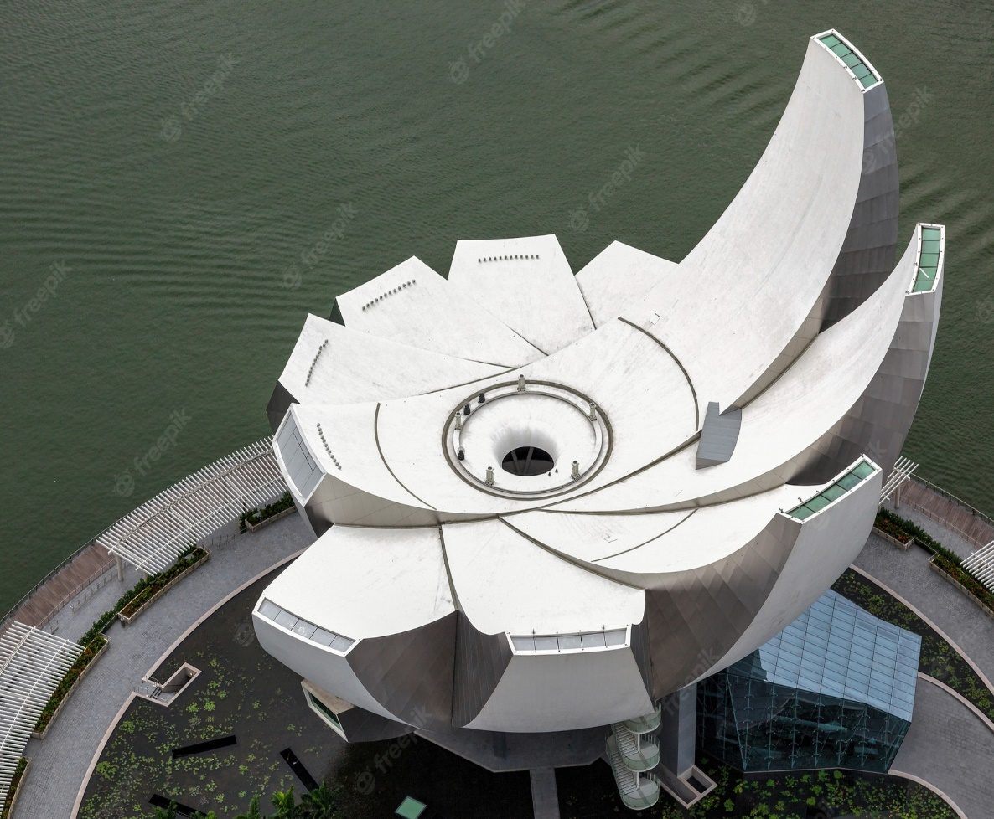

**Fig 5.1 Geometry of flower**

**CHAPTER - 6**

**METHODOLOGY**

**CHAPTER 6**

# **METHODOLOGY**

The museum is organized as two major exhibition spaces, positioned around a central open-space atrium. The first exhibits hover within a sculpturally shaped form over the promenade, and a second collection of gallery spaces are located beneath a large water lily garden. The building is supported by a steel lattice diagrid structure and ten steel columns –a sculptural centerpiece that allows the building to seemingly float above. The geometry of the shape is often compared to a lotus, and is clad with fiber-reinforced polymer (FRP), typically used in high-performance racing yachts. The upper galleries are organized into 10 halls that vary from double height vertical spaces, to long horizontal rooms. Each hall has access to daylight from skylights above and from the central atrium. Integrated lighting control mechanisms allow the spaces to be transformed to black boxes. Large picture windows from within the galleries offer views to the promenade below.

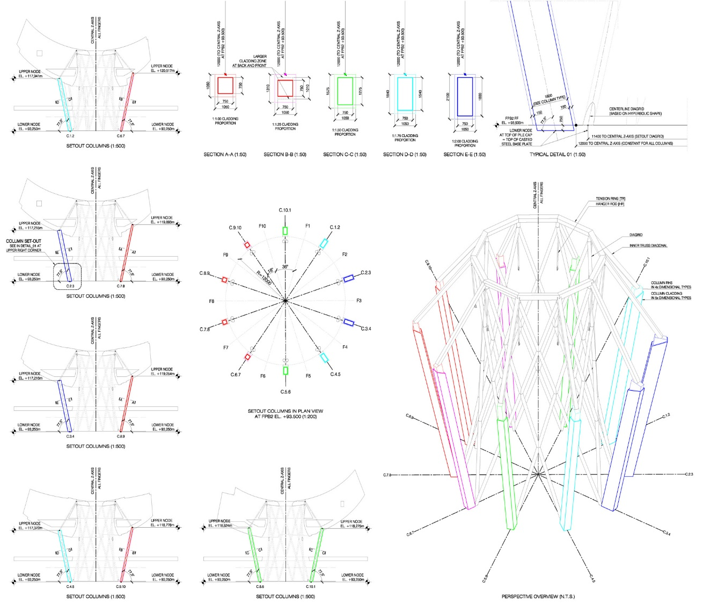

**Fig 6.1 Reinforcement data**

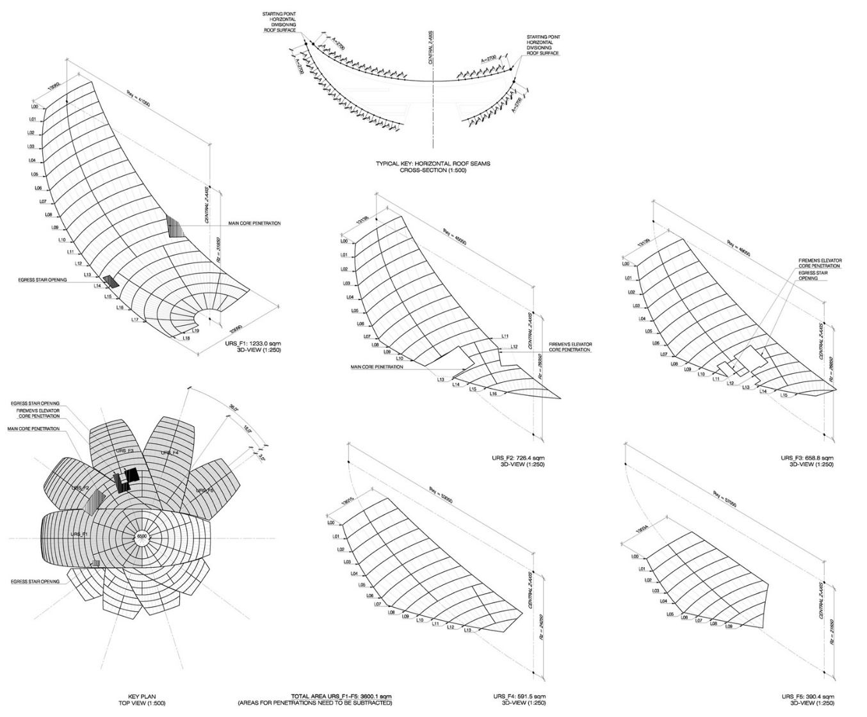

**Fig 6.2 Flower data**

**CHAPTER - 7**

**MODELLING & CO-ORDINATION**

**CHAPTER 7**

# **MODELLING & CO-ORDINATION**

The highly complex geometry of the lotus shape led the design team to use parametric modelling techniques for the structural steel skeleton. **MSA developed a Rhino** model to generate the surface profiles, and then used these surfaces to develop a parametric model of the steel work centerlines using **Bentley’s** Generative Components software. The centerline model was then exported to generate a space frame analysis model of the roof in **GSA program**, and following analysis and section size definition, the GSA analysis model was imported. On completion of the 3-D drafting, the model was exported and issued to the steel work contractor as the basis for them fabricate on model. The Micro Station model was also used to generate a record set of 2-Ddrawings for the project.

Stunning architectural marvels, however, are frequently building challenges as they use unusual shapes joined together. Translating these stunning visions into standing structures was no easy feat but Yongnam Engineering and Construction was up to the task. Yongnam is an engineering firm based in Singapore and was responsible for doing the detailing and fabricating of the steel skeleton of the ArtScience Museum. The architects gave Yongnam a wire frame model as well as the 3D model. With this, Yongnam’s designers then re-drew everything within Tekla BIM software to produce the relevant workshop drawings for each part of the museum. These workshop drawings would then be used to fabricate the steel structures needed for the museum’s unusual design. Detailing and fabricating the curved structures were a design challenge. “The museum is a complicated structure and the steel members had different geometries,” noted Arnold C. Hipolito, the Deputy Engineering Manager at Yongnam.

“You need to know the coordinates in order to get the correct geometry of all the members.” Getting the geometry wrong would mean that the parts would not fit. The need for precision made Tekla software a crucial tool for Yongnam. The detailers used Tekla to produce the workshop drawing which was sent to the consultant for approval. After approval, the detailed workshop drawing was sent to Yongnam’s workshop for fabrication. In all, Yongnam produced about 5,000 steel parts and their respective workshop drawings. Apart from workshop drawings, Yongnam also used Tekla BIM software to create erection drawings and orientation drawings so that the different parts could be fitted together on site. Tekla has played a big role in reducing the time it took to model the structure of the ArtScience Museum. Because the structure is so complex, if we didn’t have Tekla, the drawings would have taken five times longer.

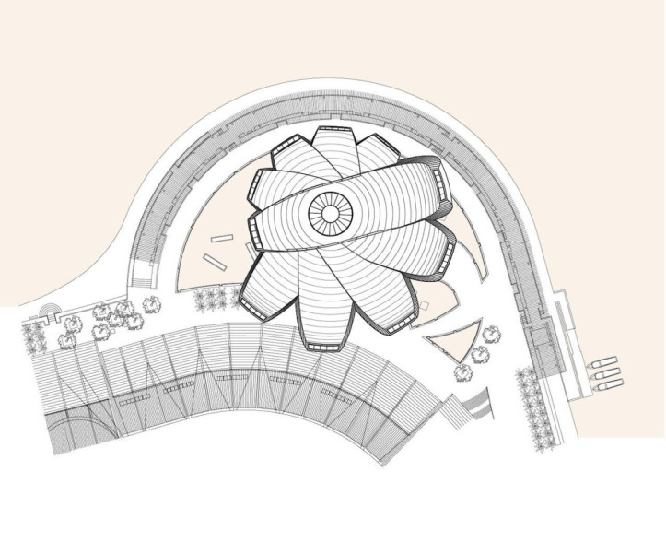

The entire process of designing and fabricating the steel parts for the ArtScience Museum took about two years. It was eventually opened in February 2011, and has become a major attraction.

**CHAPTER - 8**

**STRUCTURAL DATA**

**CHAPTER 8**

# **STRUCTURAL DATA**

**STRUCTURAL SCHEME:**

* Each petal is formed by secondary members spanning onto primary girders, which load side trusses that bend downwards in cantilever action. The side trusses of adjacent petals meet at waler beams which resist out-of-plane forces caused by the steps in the roof between each petal. Loads from the side trusses are resolved at the waler beams and transferred to the radial mega-trusses.
* These act as cantilevers, taking the museum loads to the vertical supports which consist of a central diagrid structure and a series of10 mega-columns, inclined outwards.
* Tensile loads in the top chords are resolved into the tension ring which connects to the top of the diagrid, while the compressive loads are resolved into the compression ring below. The vertical loads are carried by the inclined mega-columns.

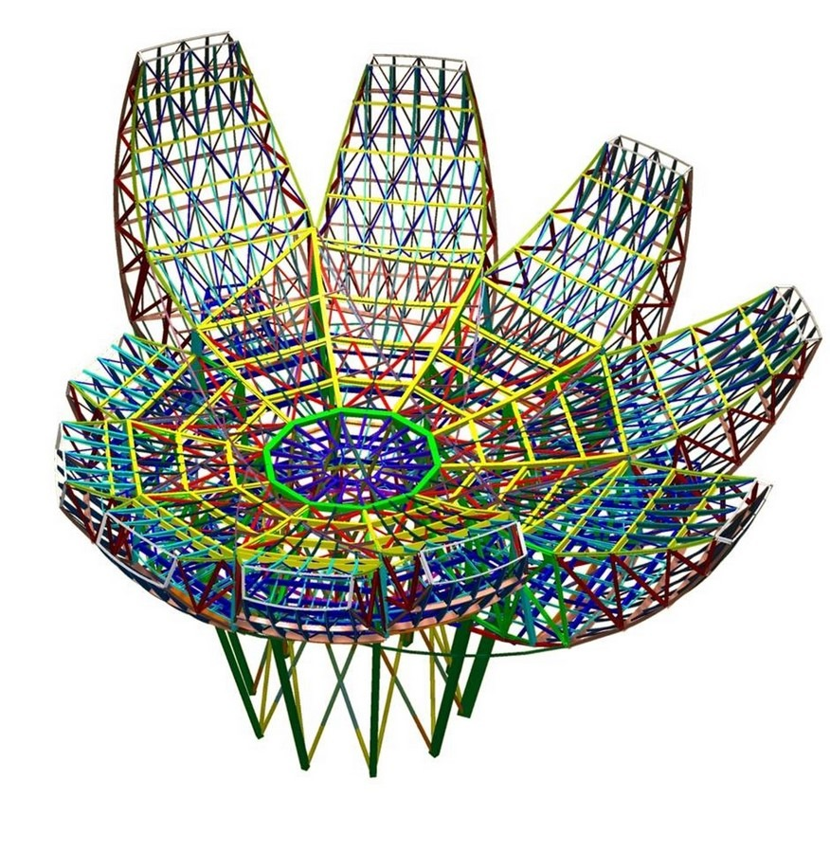

**Fig 8.1 Structure of ArtScience Museum**

**STRUCTURAL DATA:**

Cantilevered gallery trusses with 24-inch by 24-inch box section chords were employed to carry the galleries. However, these posed a significant challenge as their large reactions demanded resolution where they met the atrium, precisely where the architectural form was intended to run unencumbered. In response, Arup devised a system of tension and compression rings encircling a central hyperbolic diagrid of straight 20-inch diameter circular hollow steel sections. The gallery trusses are configured to deliver the large horizontal forces from their top chords into the 30-inch by 30-inch steel tension ring, built up from 2-inch thick steel plates along the top of the diagrid. Any net horizontal forces on the tension ring, whether caused by wind, earthquake, or unbalanced gravity loads, are carried to the ground through the diagrid via shear and overturning action. Forces from the diagonals and the bottom chords are carried by a spiraling 35-inch square compression ring built from 2-inch plates and by an inclined colonnade of 71-inch by 30-inch built-up steel box mega-columns welded from 19/16-inch steel plate.

The compression ring encircles but does not touch the diagrid, thereby protecting the diagrid from the large horizontal thrusts generated along bottom chords of the gallery trusses. The diagrid also provides a necessary screen between the galleries and the atrium, creating a sense of enclosure to each gallery while still encouraging views among the spaces. In this way, the diagrid serves to differentiate the interior spaces of the museum while also providing overall stability to the structure. Such duality of purpose underscores the overall design principles of the museum. Arup employed a suite of design and modeling programs including X-Steel, Rhino, Micro Station Triforma, and Oasys GSA to create three-dimensional engineering models of all buildings within the development. Once created, these were then cross-checked against the architectural models (Figure 5). By utilizing these tools early and regularly throughout the design process, the team was able to evaluate, modify, and re-analyze a wide range of design options for the irregular and complex form of the museum. Once the design was complete, Arup provided the fabricator with geometrically accurate design models to facilitate the production of shop drawings. In this way, the architectural team, the engineering team, and the fabricator were necessarily working from a common geometry. This approach eased coordination and accelerated the shop drawing review process considerably.

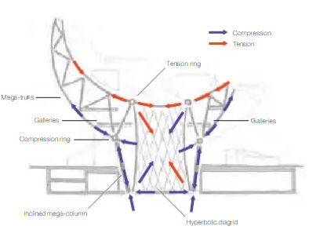

**Fig 8.2 Structural data**

Tension and compression rings resist the push-pull action of the cantilevering mega trusses which support the elevated galleries of the ArtScience Museum. The hyperbolic diagrid provides primary lateral stability to the entire system. Courtesy of Patrick S. McCafferty.

**CHAPTER - 9**

**FEATURE EXHIBITION**

**CHAPTER 9**

# **FEATURE EXHIBITION**

The ArtScience Museum features gallery spaces totaling 50,000 square feet (6,000 square meters) for exhibits from combined art/science, media/technology, as well as design/architecture motifs. Permanent exhibits include objects indicative of the accomplishments of both the arts and the sciences through the ages, along the lines of Leonardo da Vinci's Flying Machine, a Kongming Lantern, and a high-tech robotic fish. The museum opened with an exhibition of a collection of the Belitung shipwreck cargo, and Tang dynasty treasures that were discovered and preserved by Tillman Walter fang of Seabed Explorations NZ Ltd.

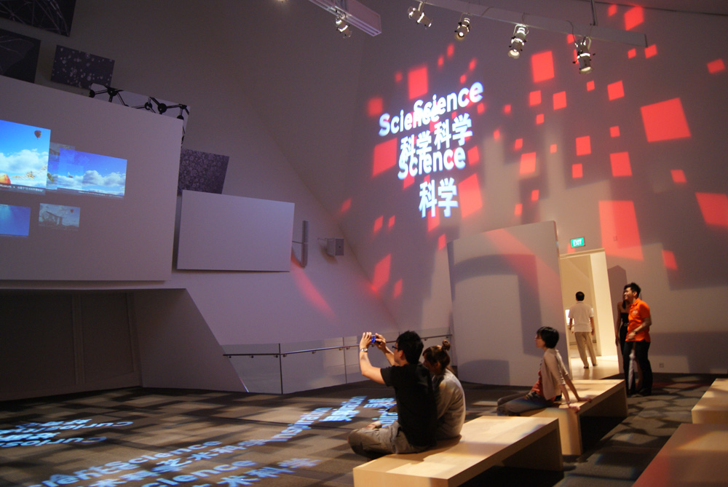

**Fig 9.1 Exhibition**

**CHAPTER - 10**

**REFERENCES**

**CHAPTER 10**

**REFERENCES**

* "About ArtScience Museum". Marina Bay Sands. Archived from the original on 3 July 2013. Retrieved 10 July 2013.
* "Design: Architecture in Bloom - Singapore's ArtScience Museum". Time. 177 (14): 52–53. 11 April 2011.
* Jump up to: “Travel the ancient Silk Road for the first time Asia". www.marinabaysands.com. Archived from the original on 11 February 2011. Retrieved 28 March 2011.
* "Ninth century Tang archaeological finds go on display at Integrated Resort Marina Bay Sands' latest architectural showpiece". Archived from the original on 2011-10-02. Retrieved 2011-03-28.
* "Van Gogh's masterpieces come alive at Marina Bay Sands' ArtScience Museum". Archived from the original on 12 April 2011. Retrieved 24 April 2011.
* "Explore the distorted reality of Dalí: Mind of a Genius – The Exhibition at ArtScience Museum at Marina Bay Sands". Archived from the original on 26 April 2011. Retrieved 24 April 2011.
* ArtScience Museum at Marina Bay Sands hosts the first Cartier Time Art exhibition in Asia" (PDF). Archived from the original (PDF) on 2012-05-17. Retrieved 2011-10-20.
* "Largest collection of Warhol's artworks ever displayed in Singapore at ArtScience Museum" (PDF). Archived from the original (PDF) on 2012-03-23. Retrieved 2012-02-09.
* "Experience the Magic of HARRY POTTER: THE EXHIBITION for the First Time in Asia at ArtScience Museum, Singapore" (PDF) (Press release). Marina Bay Sands. Archived from the original (PDF) on 2012-05-17.
* "ArtScience Museum zooms in on Outside In: A Magnum Photos Showcase" (PDF). Archived from the original (PDF) on 2012-10-05. Retrieved 2012-11-09.